[News Article Draft V3 – Summit Website]

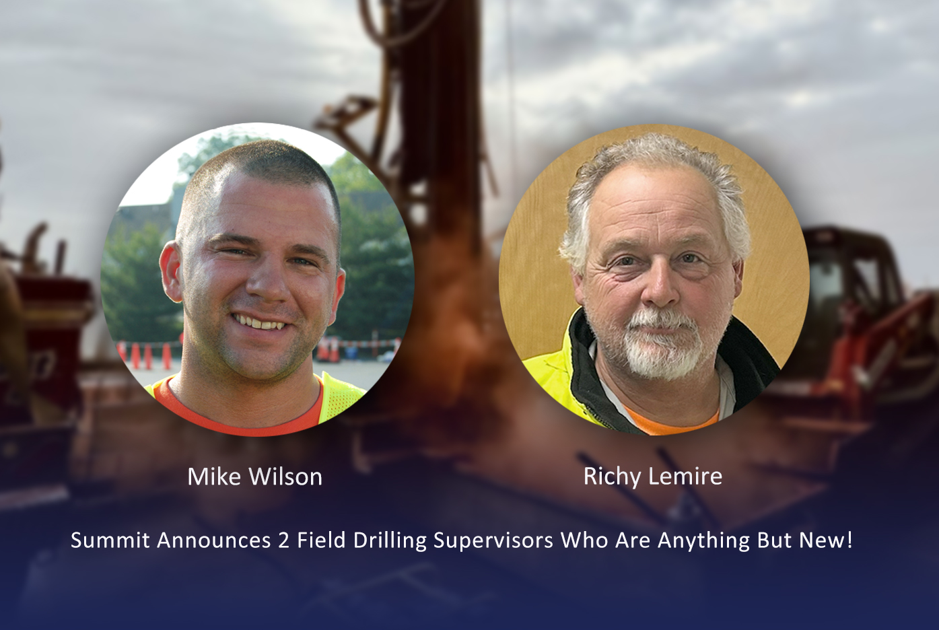

Introducing Summit’s Drilling Field Supervisors

Experienced Leadership Where It Matters Most—In the Field

Summit’s goal has always been clear: to be the best-in-class environmental services company on the East Coast. Achieving that standard requires more than advanced equipment and regional reach, it requires exceptional leadership in the field and a relentless commitment to our clients.
To further strengthen that commitment, Summit has created a new leadership role: Drilling Field Supervisor.

While the title is new, the experience behind it is anything but. Mike Wilson and Richy Lemire, collectively bring more than 50 years of environmental experience, having earned the respect of peers, project managers, and clients alike through decades of hands-on leadership. These seasoned professionals now serve as a critical bridge between field operations, on-site client engagement, and office management.

What Drilling Field Supervisors Do

Summit’s Drilling Field Supervisors focus on four core priorities that directly impact project success:
• Advance safe drilling operations through active oversight, mentoring, and field presence
• Ensure best-in-class quality by reinforcing consistent drilling practices across crews
• Develop and mentor field teams, strengthening skills, confidence, and career pathways
• Serve as a client interface, ensuring clear communication and positive on-site experiences

Beyond these core responsibilities, Field Supervisors provide hands-on support where it matters most stepping in to stabilize challenging projects, overseeing large multi-crew operations, mentoring new drillers, and serving as a trusted escalation point for both field staff and clients.

Driving Continuous Improvement

Since introducing this role, Summit has already seen measurable results:
• Stronger field-to-office communication
• Improved safety performance and consistency
• Higher field morale and engagement
• More proactive issue resolution and client satisfaction

This role creates a true feedback loop—capturing real-time insights from the field and translating them into operational improvements across the organization.

Looking Ahead

As Summit moves into 2026, the Drilling Field Supervisor role will become an even greater focus, supporting the recruitment of skilled helpers, expanding training programs, and building the next generation of field leaders. It is another step forward in Summit’s ongoing investment in people, performance, and partnership.

Because exceptional results start with exceptional leadership, right in the field.

